**Test Horizen’s TokenMint Platform and Cobalt Web Wallet on Testnet #51**

**STEPS**

Test is done on a Windows 10, Brave browser

1. Download and install Sphere by Horizen Testnet as per TokenMint blog post

* Used the Link: <https://github.com/HorizenOfficial/Sphere_by_Horizen_Testnet/releases/tag/desktop-v1.3.0-beta-testnet>
* Comment/Suggestion: It would be nice if the download link is on the Horizen Website instead of github. Non-technical people would be more comfortable downloading there.

2. Create a new wallet in Sphere by Horizen Testnet and get testnet ZEN from the HEAP Portal (Lookup the transaction on the Horizen testnet block explorer, paste explorer transaction link in your submission)

* Used the Link: <https://heap.horizen.io/>

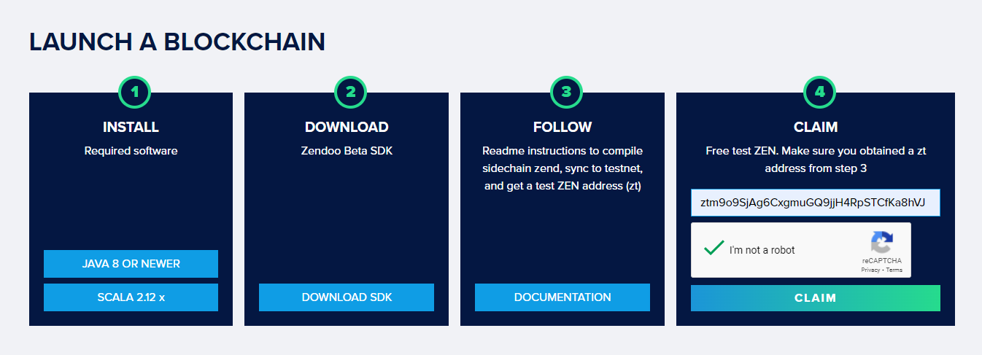

* Transaction Link: <https://explorer-testnet.horizen.io/tx/fe6fd4864699ed8c3cb0193046995d39baaac6e86510317670a29f5c87af501c>
* Comment/Suggestion: The Testnet Sphere Wallet is almost identical to the existing Sphere Wallet. Everything went smoothly.

3. Download and install Cobalt web wallet. Also, follow instructions in TokenMint blog post to get “Test Pilot” Discord badge (provide your Discord username in your submission)

* Downloaded Cobalt Link: <https://github.com/HorizenOfficial/cobalt-wallet/releases/tag/1.0.0.9>

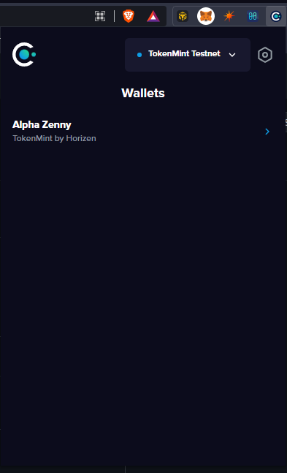

* Discord Username: Chris123

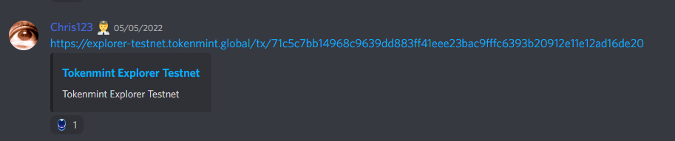

* Comment/Suggestion: Cobalt pretty similar to other Browser Based Wallets like BSC and Metamask. Color choice is perfect specially for darkmode users like me.

4. Make a Forward transfer of tZEN from Sphere by Horizen Testnet to Cobalt - correct sidechain ID in Sphere by Horizen Testnet is 05612f21...7450f3d1 (Lookup the transaction on the Horizen testnet block explorer, paste explorer transaction link in your submission)

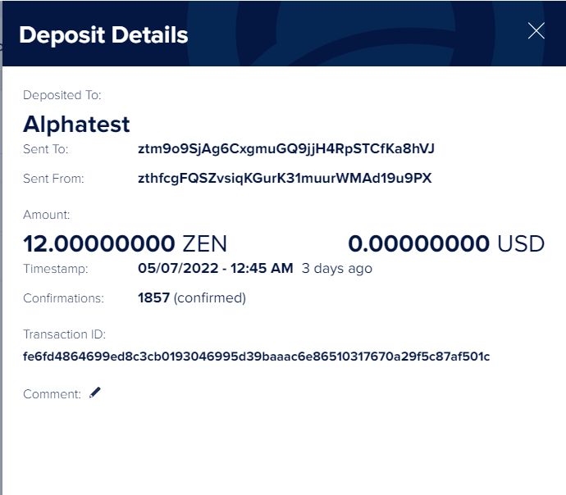

* Transaction Link: <https://explorer-testnet.horizen.io/tx/fe6fd4864699ed8c3cb0193046995d39baaac6e86510317670a29f5c87af501c>
* Comment/Suggestion: This is actually a very good feature of Horizen. In Moonbeam, you have to bridge your DOT before you can move it from parachain to relay chain. Here in Horizen, you can do it directly via the wallet, from mainchain to sidechain.

5. Transfer 1 TZNY from Cobalt wallet to this address: e259c170f497cb266021d91b7eca983bf5bb32e8125c1fe2a76ed277021592d2 (Lookup the transaction on the TokenMint block explorer, paste explorer transaction link in your submission)

* Transaction Link: <https://explorer-testnet.tokenmint.global/tx/deb3c2f3edf41e71ac4446ac1dcea514bdaa5c14c38ae7b22399ebc0b0171cdd>

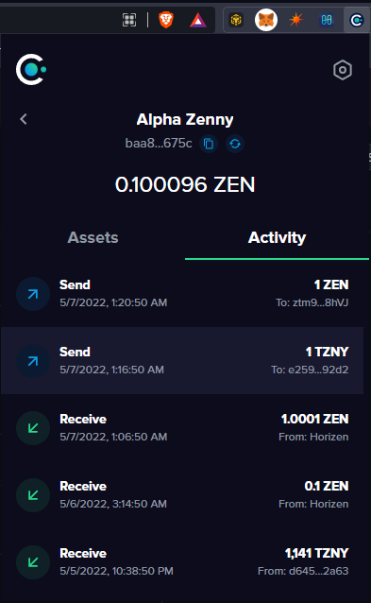

* Comment/Suggestion: Transaction speed is fast. It would be nice if the Activity Tab is linked to the blockchain explorer website. That would make transaction tracking easier.

6. Make a Backward transfer of at least 1 tZEN from Cobalt to Sphere by Horizen Testnet (Please note that the current Epoch for the TokenMint sidechain is 900 blocks (~37.5 hours) and you will have to wait for two epochs (up to 3 days) for the Backward transfer to display and become spendable (Lookup the transaction on the TokenMint block explorer AND Horizen testnet block explorer, paste explorer transaction links in your submission)

* Transaction Link: <https://explorer-testnet.horizen.io/tx/45ed5c30a11900204c9ed15e50ca2995c34c0c7922642bbc0cdc1a4a3a9d012f>
* Transaction Link: <https://explorer-testnet.tokenmint.global/tx/e095d0824c8c73a5469c752cbd03f0a4d3bae1ee95b4e163dcb2f35c33649d14>

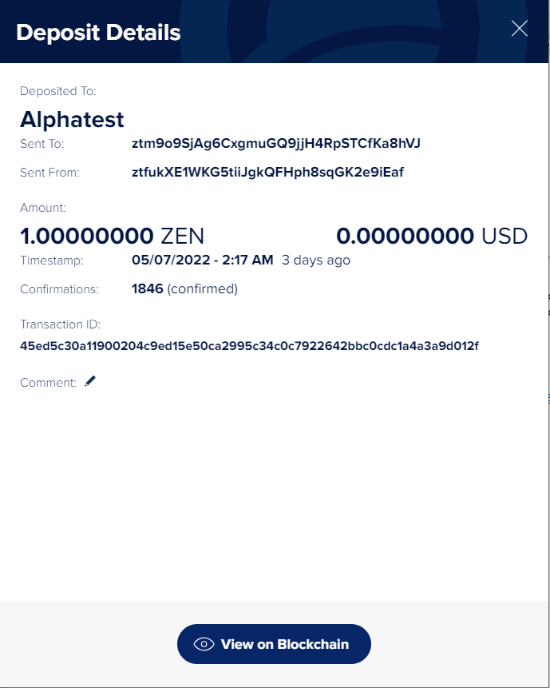

* Comment/Suggestion: It took a while but its good. If it’s a permanent design feature, it would be nice to have a disclaimer in the wallet.

**FEEDBACK ON SPHERE, COBALT and EXPLORER**

1. Sphere – One of the strongpoints of Horizen is that it is one of the most decentralized L1 blockchains out there. It might be a good idea to make it easier for users to run on full node without overloading their hard drive. This means having an option on the Sphere Wallet to store ledger data on a specific drive or subdirectory. Another good thing to have on Sphere is darkmode.
2. Cobalt – Works like Metamask. The color scheme is great for darkmode users like me. It would be nice if the activities tab is clickable and linked to the blockchain explorer.
3. Tokenmint Explorer – Looks good. It would be nice though to see some stats and charts similar to the ones in etherscan and bscsan.

DISCORD USERNAME: Chris123

BOUNTY ADDRESS: znbQsR49UcfAzR4Bwy75pRZ9gb9dx79Laay